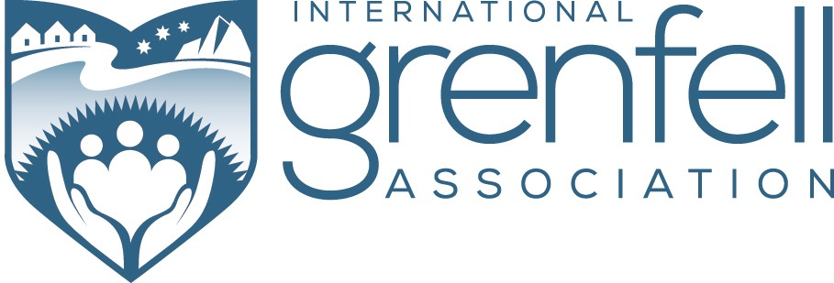

IGA MUSIC PROGRAM - Phase 2

Program Coordinator

The International Grenfell Association is seeking a highly skilled and dynamic individual capable of leading music development in communities across South Labrador and the Northern Peninsula.

The aims of the IGA Music Program are to:

- to strengthen the position of music in community life
- to create access to musical training and encourage musical talent across all generations
- to use musical development to empower leadership skills in young people
- to create opportunities for musicians at all skill levels to meet and perform
- to nurture exceptional talent and offer bursary support to those seeking careers in music
- to build networks, partnerships and sponsorship to support ongoing music development

This Phase 2 initiative is an extension of the IGA Music Program. The Program Coordinator will have the vitally important role of designing and implementing phase 2 of the Program. It is a new appointment within the IGA and will be established on a two year contract with a renewable option.

The position will be based at an office in St Anthony and involve travel to the communities of Cartwright south to L’anse au Clair; on the Northern Peninsula from St Anthony south to Flowers Cove/St Barbe; and include Main Brook, Roddickton and surrounding communities.

A full job description can be viewed on the IGA website at www.grenfellassociation.org.

Applications (together with three references) should addressed to:

International Grenfell Association
(Music Program Coordinator Position)
Box 75, 430 Topsail Road
St. John’s, NL
A1E 4N1
Or by Email at iga@nfld.net (please include “Music Program Coordinator Position” in the subject line).

Questions about this opportunity can also be addressed to the International Grenfell Association at (709)745-6162.

The IGA helped launch the first phase of a very successful music program in Nunatsiavut that is still very much in place. For information on this program, please visit www.facebook.com/TNNBB.

The deadline for applications is July 31, 2017.

